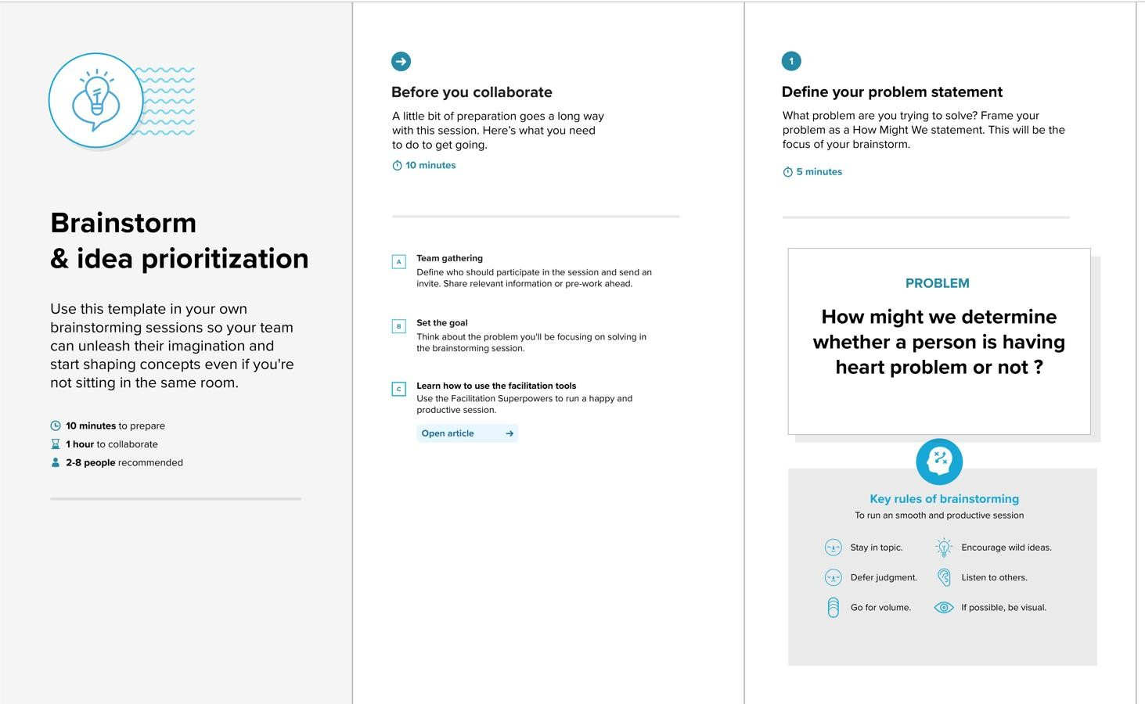**Ideation Phase Brainstorm & Idea Prioritization**

**Brainstorm & Idea Prioritization Template:**

Brainstorming provides a free and open environment that encourages everyone within a team to participate in the creative thinking process that leads to problem solving. Prioritizing volume over value, out-of-the-box ideas are welcome and built upon, and all participants are encouraged to collaborate, helping each other develop a rich amount of creative solutions.

**Step-1: Team Gathering, Collaboration and Select the Problem Statement**

# Step-2: Brainstorm, Idea Listing and Grouping

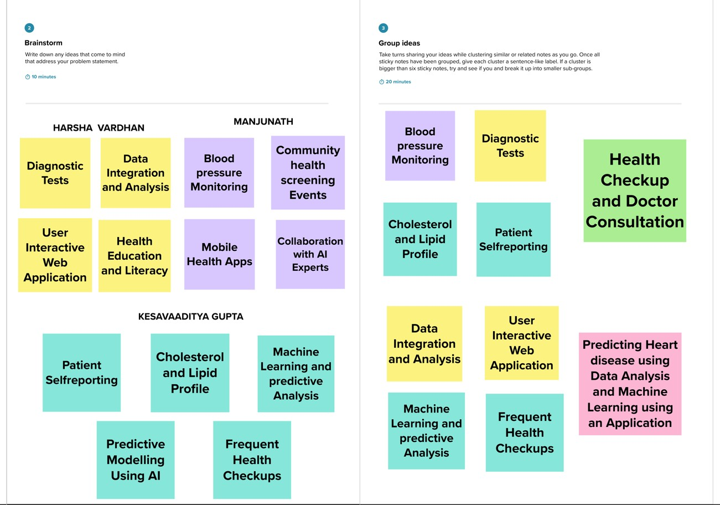

# Step-3: Idea Prioritization

